# 

# An incubated co-working space for technology innovation

## PMBOK, TOGAF and ITIL Proposal Document

**Team Heroes**

Table of Contents

1

An incubated co-working space for technology innovation 1

PMBOK, TOGAF and ITIL Proposal Document 1

Document Change Log ii

Definition of Terms iii

Description of Acronyms iv

1 Document Overview 1

1.1 Introduction and Purpose 1

1.2 PROCESSES 1

1.3 USES AND APPLICATION 4

# Document Change Log

This is a working document, which will be maintained with time. Team members, please ensure that any changes are recorded in the change log below – this is to ensure that each team member is always clear about which changes have been made and when.

|  |  |  |  |
| --- | --- | --- | --- |
| **Version** | **Date** | **Author** | **Description** |
| 0.01 | 21 March 2015 | Malusi Gcakasi | Created initial template document. |
|  |  |  |  |

# Definition of Terms

|  |  |
| --- | --- |
| **Member** | Role Description |
| Mdabula Nikiwe | Team Leader |
| Nonkenge Thabo | Member |
| Qebelu Siphokazi | Member |

# Description of Acronyms

|  |  |
| --- | --- |
| **Acronym** | **Description** |
| CH | The Cortex Hub |
| CT | Central Team |
| RT | Remote Team |
| PMBOK | Project management body of knowledge |
| TOGAF |  |
| ITIL | Information Technology Infrastructure Library |
| IT | Information Technology |
| OGC | Office of Government Commerce |

# Document Overview

## Introduction and Purpose

The Project Management Body of Knowledge (PMBOK) is a collection of processes and knowledge areas generally accepted as best practice within the project management discipline. This describes the sum of knowledge within the profession of project management.

This full body of knowledge includes knowledge of proven, traditional practices, which are widely applied, as well as knowledge of innovative and advanced practices, which may have seen more limited use. PMBOK consist of 5 phases:

[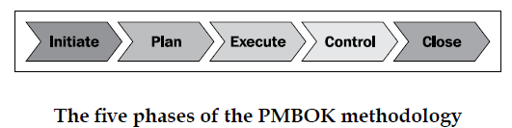](https://www.google.co.za/url?sa=i&rct=j&q=&esrc=s&source=images&cd=&cad=rja&uact=8&ved=0CAcQjRw&url=https://www.packtpub.com/books/content/roles-and-responsibilities-records-management-implementation-alfresco-3&ei=WgFaVenHC6fd7Qb_hIDICg&bvm=bv.93564037,d.ZGU&psig=AFQjCNFLYo5l5VAPl2BGofZXCqgm19Lgpg&ust=1432037483411004)

## PROCESSES

**PMBOK PROCESSES**

[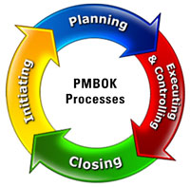](http://www.google.co.za/url?sa=i&rct=j&q=&esrc=s&source=images&cd=&cad=rja&uact=8&ved=0CAcQjRw&url=http://www.mpmm.com/project-management-best-practices.php&ei=79ZZVdGtBquu7ga-qoKgBw&bvm=bv.93564037,d.ZGU&psig=AFQjCNFLYo5l5VAPl2BGofZXCqgm19Lgpg&ust=1432037483411004)

ITIL

ITIL (IT Information Library) is a framework proposed by the United Kingdom's OGC (Office of Government Commerce) that gathers together in a series of books the best practices in the area of managing IT services. The ITIL library was started in the early 1980s by the British government with the goal of improving the service provided by their IT departments.

THE GOAL

Is to provide the managers of IT systems with the tools and documents that will allow them to improve the quality of their services, i.e. improve client satisfaction while meeting the strategic goals of their organization. To do this, the IT department must be considered to be a series of closely linked processes. Pragmatically, ITIL meets the logic of making IT serve employees and clients rather than the other way around.

THE SCOPE

ITIL is divided into nine areas (that correspond to nine books) that cover all of the problems encountered by IT systems managers:

•Service Support

•Service Delivery

•Infrastructure Management

•Applications Management

•Service Management

•Business Perspective

•Business Requirements

•Technology

[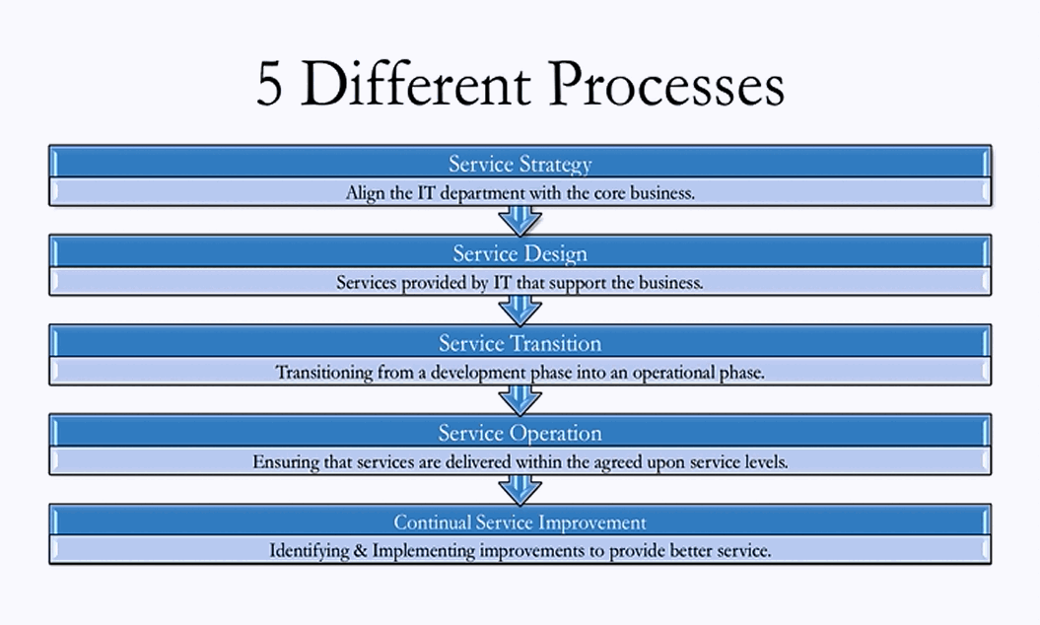](http://www.google.co.za/url?sa=i&rct=j&q=&esrc=s&source=images&cd=&cad=rja&uact=8&ved=0CAcQjRw&url=http://www.helpdesksoftware.biz/what-is-itil/&ei=rhVaVcTLEvOIsQSBooHoCg&bvm=bv.93564037,d.ZGU&psig=AFQjCNHZKA9QulLaHV3XwpS7H5SwitJ0jw&ust=1432053525026679)

## USES AND APPLICATION

[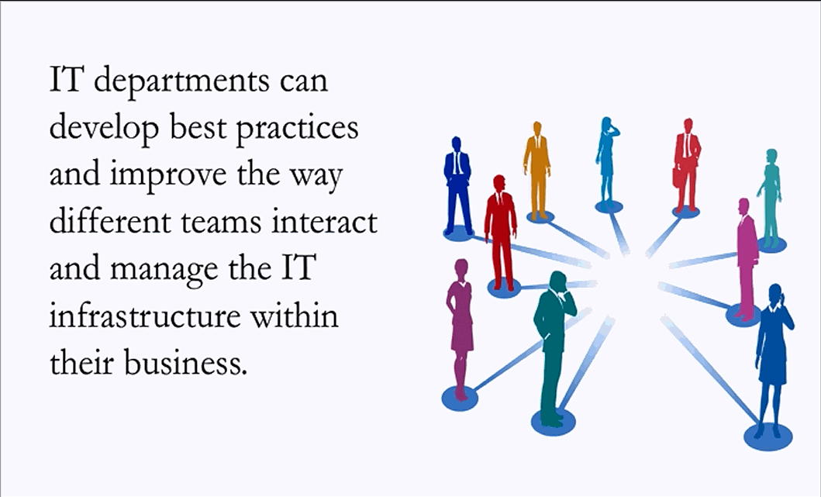](http://www.google.co.za/url?sa=i&rct=j&q=&esrc=s&source=images&cd=&cad=rja&uact=8&ved=0CAcQjRw&url=http://www.helpdesksoftware.biz/what-is-itil/&ei=AARaVdq0JJDY7AaBwYIY&bvm=bv.93564037,d.ZGU&psig=AFQjCNGqhGbzs9NxXBBM2NHVB2MaVtDqHQ&ust=1432048993487319)

# TOGAF

2.1 What is TOGAF

TOGAF is an Open Group Standard, is a proven enterprise architecture methodology and framework used by the world's leading organizations to improve business efficiency. It is the most prominent and reliable enterprise architecture standard, ensuring consistent standards, methods, and communication among enterprise architecture professionals. Enterprise architecture professionals fluent in TOGAF standards enjoy greater industry credibility, job effectiveness, and career opportunities. TOGAF helps practitioners avoid being locked into proprietary methods, utilize resources more efficiently and effectively, and realize a greater return on investment.

2.2 Why use TOGAF

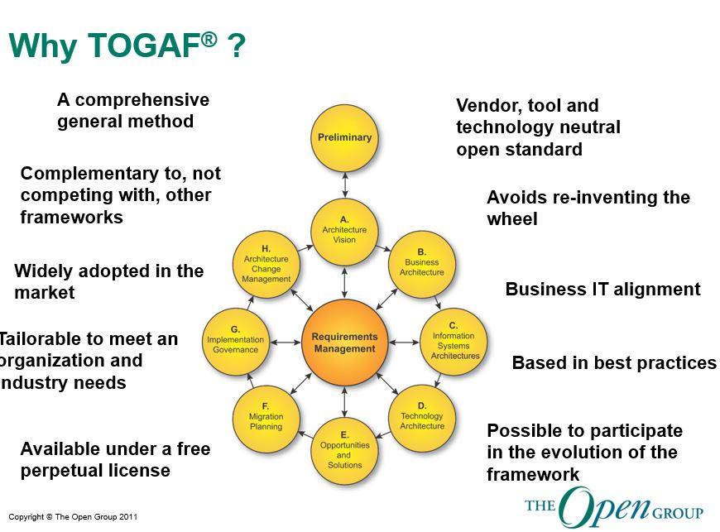

2.3 TOGAF High level

* Adopt and use TOGAF
  + Improved ability to respond to new business demands
  + Improved ability to introduce new technology
  + Greater business value from IT operations
  + Faster, simpler, cheaper procurement
  + Faster time-to-market
* Participate in the Architecture Forum
  + Worldwide forum for customers, tools vendors, solution vendors, integrators, academic & research organizations
  + Dialog with peers and industry experts
  + Practical information and experience
  + Access to work in progress
  + Vendor, technology, product neutral